**CODE FOR ASSIGNMENT1:**

**package** TestNG;

**import** org.testng.annotations.Test;

**public** **class** NewTest {

@Test (dependsOnMethods={"method2"})

**public** **void** method1()

{

System.***out***.println("20");

}

@Test(dependsOnMethods={"method3"})

**public** **void** method2()

{

System.***out***.println("30");

}

@Test

**public** **void** method3()

{

System.***out***.println("40");

}

}

**OUTPUT:**

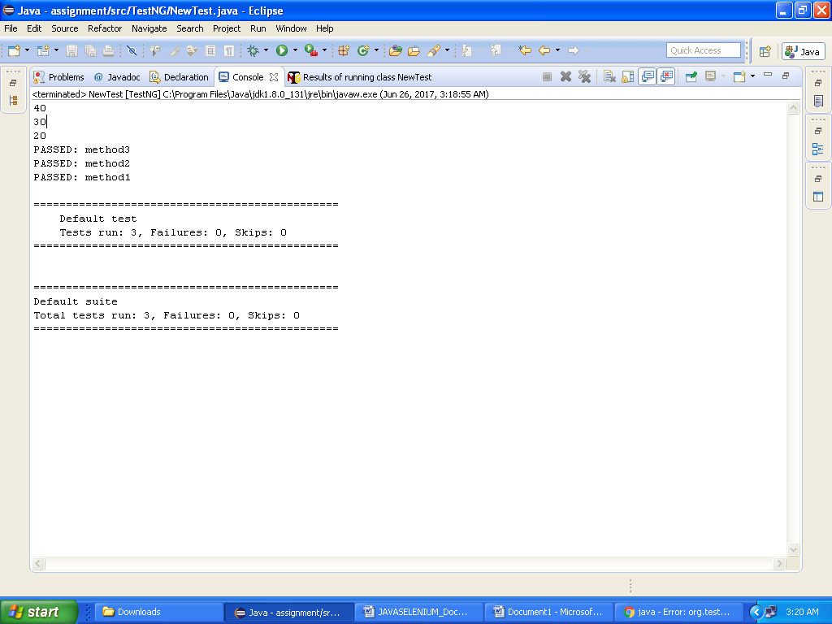

**TEST OUTPUT :**

